How to make a complaint

What is a complaint?

 | A complaint is when you feel unhappy about something.
This may happen because:
- we are doing something wrong
- we are not doing something that we should be doing.

It is okay for you to make a complaint. If you do:
• you will not get into
trouble
• or be treated in a bad
way
• or lose your care and
support.

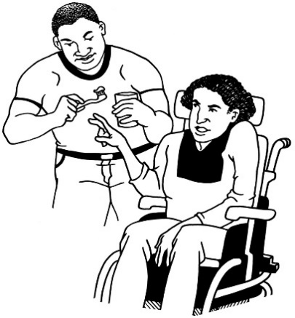 | You may want to make a complaint about:  - a person  - the care and support you are getting  - something else.
Who can help me make a complaint?

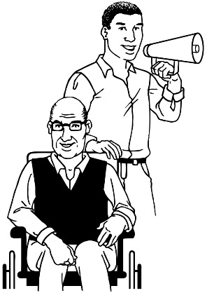 | - a family member  - a friend  - a carer  - a support worker  - an advocate (an advocate’s job is to stick up for what you want).

What should I do if I am unhappy?

Step 1:

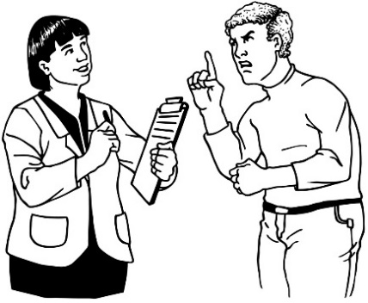 | Talk to us straight away and tell us what is making you unhappy.
 | Ask to speak to:
Skipton Registered Manager | James Elwood 01274 588990  01756 700888
Or email | care@carersresource.org

What will happen next?

 | We will try and put things right
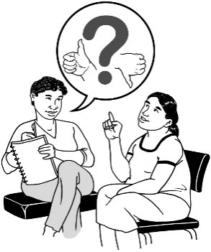 | We will explain why things went wrong.

Step 2:

If you are still unhappy, contact our Complaints Manager: Mrs Sam Dawson

You can do this by:
Letter
Unit 15
Parkview Court
St Pauls Road
Shipley
BD18 3DZ
Telephone
01274 588990
@ | Email  sdawson@carersresource.org

You can also let the Care Quality Commission know about it all or your Local Authority at any time.

CARE QUALITY COMMISSION
You can do this by: | Letter  Care Quality Commission  Citygate  Gallowgate  NE1 4PA
Telephone
0300 061 6161

@ | Their website is:  www.cqc.org.uk/contactus.cfm
LOCAL AUTHORITY
You can do this by:
Letter
Bradford Local Authority
Britannia House
Hall Ings
Bradford
BD1 1HX

Telephone
01274 435400

What we will do when you make a complaint

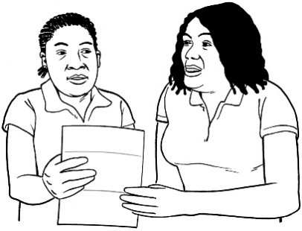 | We will let you know we have received your complaint.
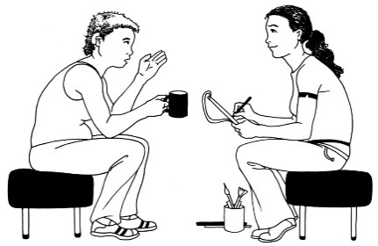 | We will contact you to talk about the problem.
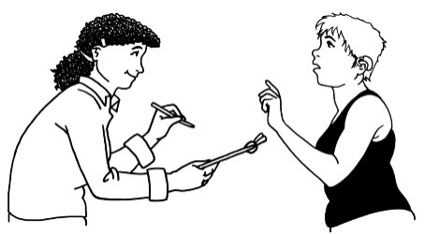 | We will help you to understand what is happening at every stage.

Help and support to make a complaint
Contact | Citizens Advice Bureau
Telephone
0344 2451282
@
If you are not happy with what we say:

You can talk to the Local Government Ombudsman. They look at complaints about people who provide care and support in order to make things better.

You can do this by:
Letter
Local Government Ombudsman
PO Box 4771
Coventry
CV4 0EH

Telephone
0300 061 0614
@ | Email  advice@lgo.org.uk

Our promise to you
We will make sure you are treated fairly and that you get the support you need all the way through the complaint process.

 | We will make sure that if you have complained it does not affect your future care and support.
 | We will be honest about when we make a mistake, will say sorry to you, explain what went wrong and put things right as quickly as we can.
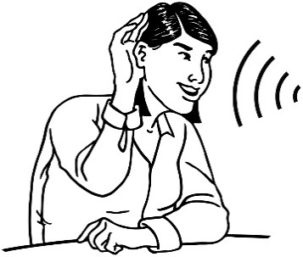 | We will listen and learn from what you say if you complain about our services. We will treat your complaint as private.

